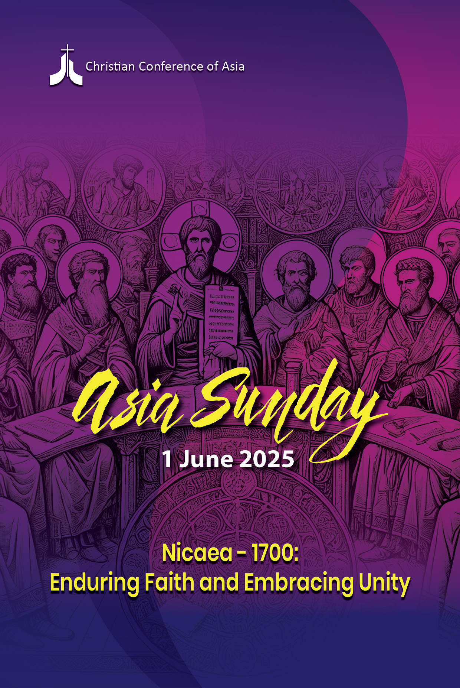

CCA General Secretary’s Introduction

Nicaea – 1700: Enduring Faith and Embracing Unity
The Asia Sunday–2025 will be observed on Sunday, 1 June, 2025. The theme of Asia Sunday-2025 is ‘Nicaea – 1700 Enduring Faith and Embracing Unity’.

As the 1700th anniversary of the Council of Nicaea held in A.D 325 is being commemorated in 2025, the Christian Conference of Asia (CCA) has decided to focus on this year’s theme in the context of Nicaea-1700 and its significance today. The Council of Nicaea, which was a pivotal moment in Church history, reverberates not just as the Nicene Creed in canonical tradition but also in the very intent of the Council of Nicaea and the resultant Trinitarian Christian faith that was affirmed predominantly in Asia seventeen centuries ago. It was primarily meant to preserve the Apostolic faith and the unity of the Church. The Nicene Creed, which stood the test of time, continues to illuminate the path of the Church, guiding it through the ever-evolving journey of faith in diverse cultural and social milieus.

The theme, ‘Nicaea – 1700: Enduring Faith and Embracing Unity’, calls for a spiritual pilgrimage to revisit the foundational tenets that have unified and shaped the identity of the Church through the corridors of history, signifying a dual commitment – first, to anchor faith in the Triune God in this challenging epoch, and second, to cultivate a spirit of unity that transcends theological differences and cultural diversities.

Jesus' teachings consistently emphasised the power of unwavering faith and love and the importance of unity. His prayer in John 17, often referred to as the High Priestly Prayer, specifically addresses the unity of the people of God, highlighting interconnectedness and oneness.

The importance of the Creed in the liturgical life of the churches can be seen in its unifying factor. Every time we recite the Creed, we strengthen our beliefs and enrich our personal and communal identity with Christ. Asian Christians are challenged to forge a collective identity that celebrates diversity while nurturing a shared commitment to the essential tenets of the Christian faith.

May the CCA’s Asia Sunday-2025 be a thanksgiving prayer of the member churches and councils of CCA to affirm our faith and unity in God while reflecting an important and historical legacy of the early Christian Church and its enduring spirit and influence on the advancement of Christianity over the centuries, which continues to serve as a means of affirming our faith and embracing unity.

Again, we respectfully urge all CCA member churches, councils, and ecumenical partners to observe Asia Sunday on 1 June 2025 and request special prayers for our faith and unity in the Triune God.

Mathews George Chunakara
General Secretary, CCA

Asia Sunday 2025
Nicaea – 1700: Enduring Faith and Embracing Unity
Order of Worship

Sound of Indigenous Instrument

Silent Meditation
Spirit of truth, guide our way,
Spirit of love, help us forgive,
Spirit of hope, never subdued,
Unite us in your goodness and peace.
Come, make us one, renew the earth.

Adapted from the Song to the Spirit
Shirley E. Murray, New Zealand

Sound of the Ching
♫ Come, O Come, Let Us Praise Parent God
(Burmese: Lajahle, htaora Hp’ya)
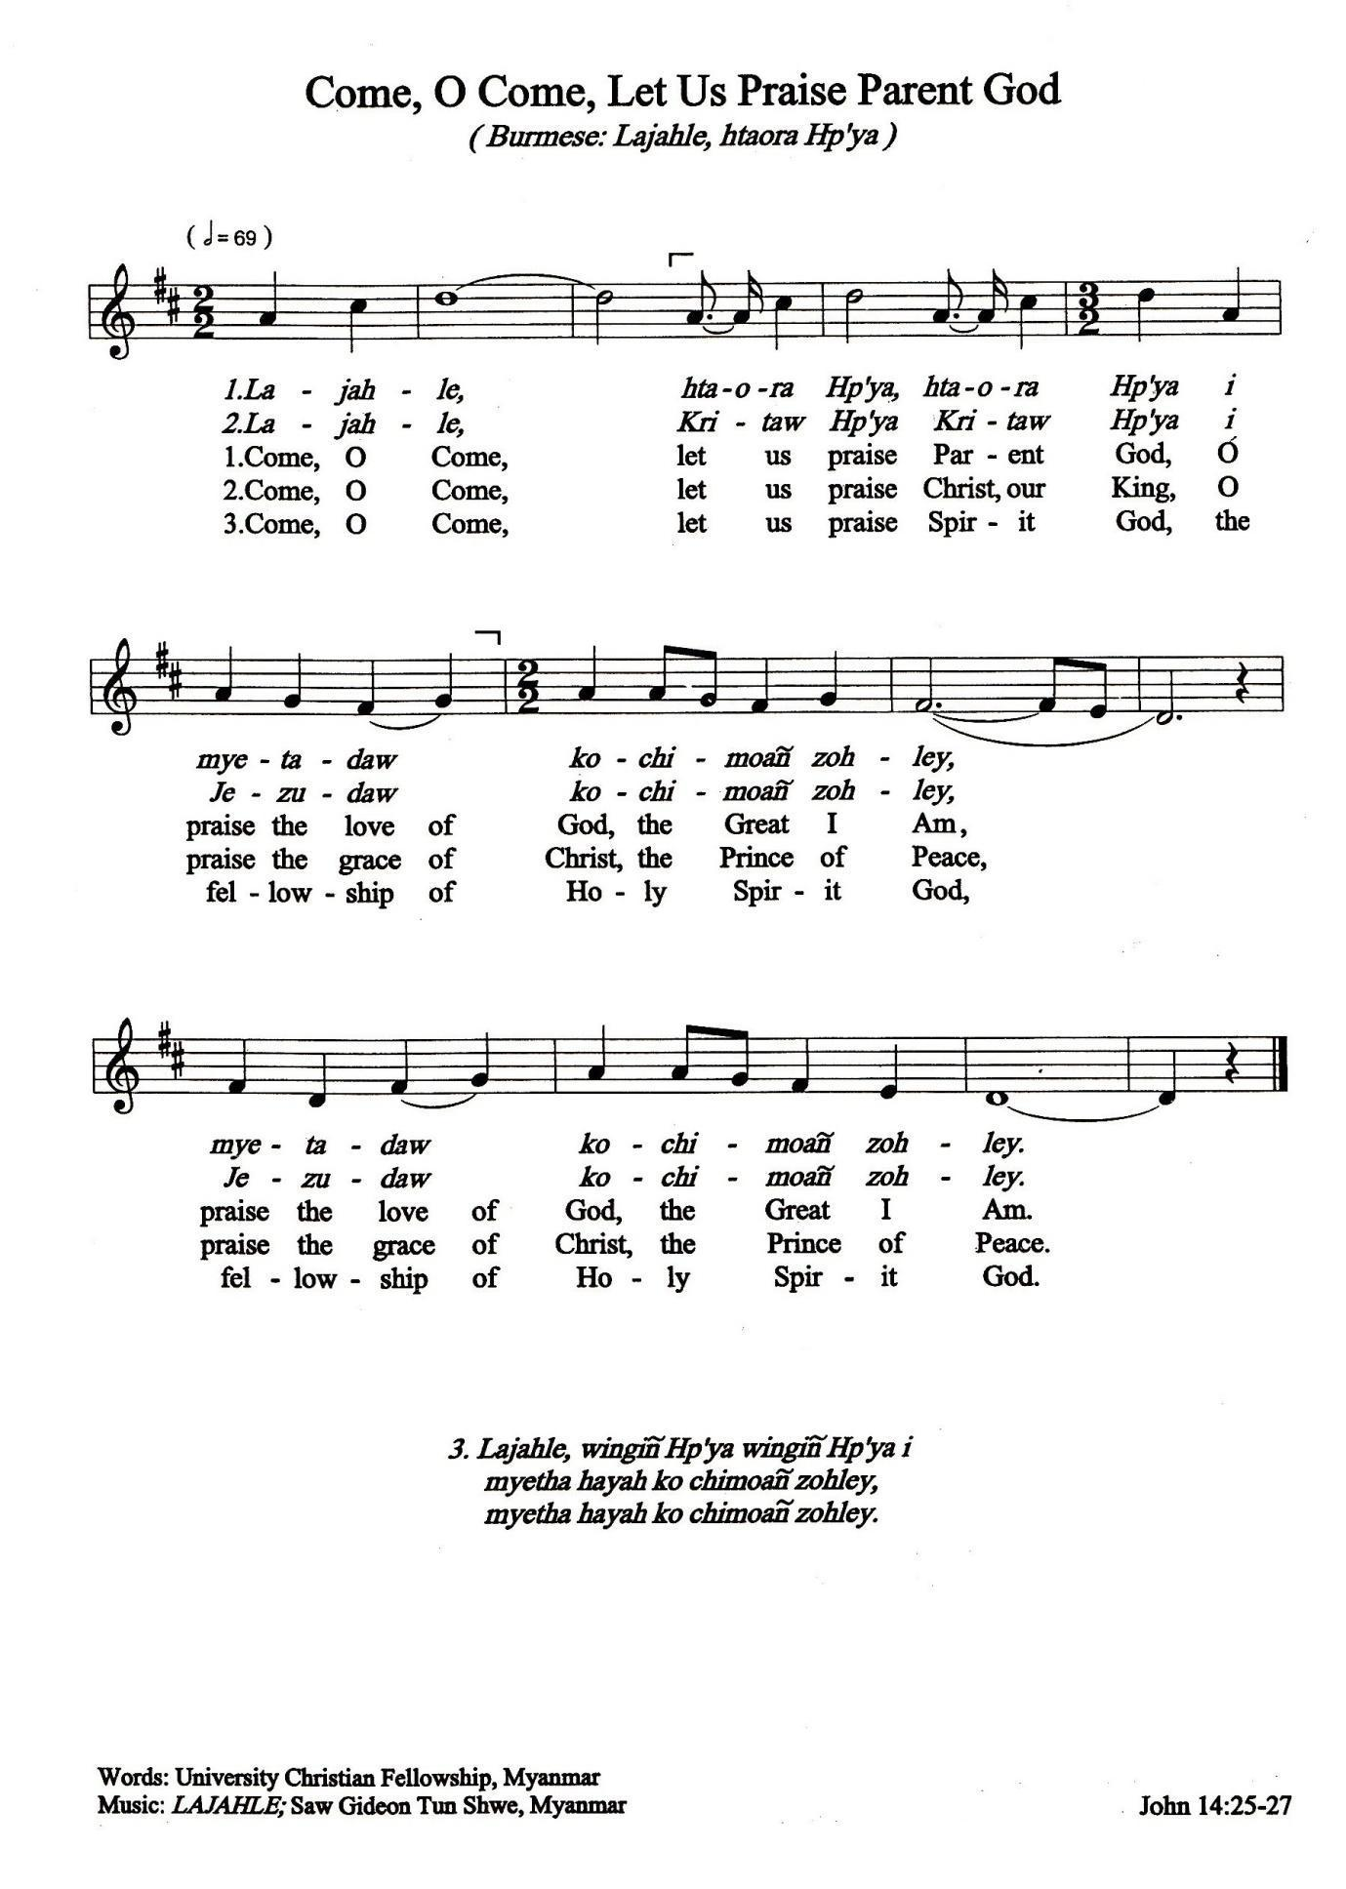

Words University Christian Fellowship, Myanmar
Music LAJAHLE; Saw Gideon Tun Shwe, Myanmar
Call to Worship
Leader: Gracious God,
you have called us from many places,
united us in one faith and gathered us in your love.
May we stand together to glorify your goodness
and rejoice in the unity you have given us.

People: Come, Holy Spirit, renew our hearts and minds.
Unite us in worship, strengthen us in faith,
and send us forth to proclaim the good news of your reign.

To you, O God - Father, Son, and Holy Spirit —
be glory and honour, now and forever. Amen.

♫ Worship the Lord, Worship the Father
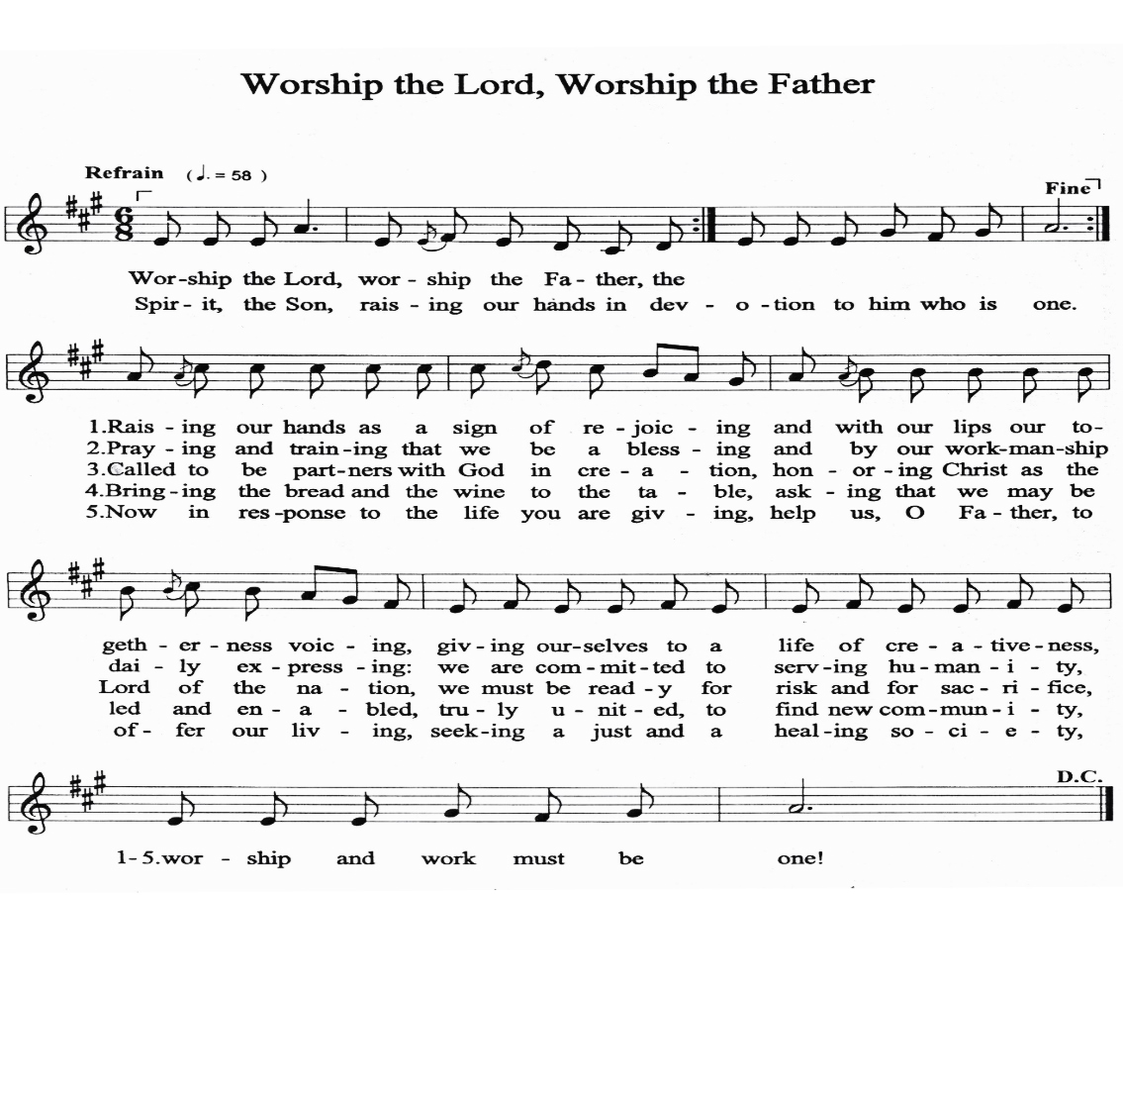

Words from May Day Service Offering Hymn
Music PIYADEVI; Traditional melody, Sri Lanka

Leader: God of all creation, we gather today as one body,
we hear you call us by name.
From diverse lands and traditions,
we come together, united in faith.
We remember the faithful assembly in Nicaea,
where your Spirit guided the Church to affirm the truth of Christ—
fully divine, fully human, our Saviour and Lord.

Through trials and triumphs, this faith crossed continents,
finding a home in the hearts of your people in Asia and beyond.
Today, we celebrate the unbroken witness of your love:
Faith that transcends borders, a unity that defies division.

People: Christ is our light, shining in every nation.
Christ is our hope, steadfast through every age.

♫ We Worship You, Creator God
(Sinhala: Namo namo mavunkarun)
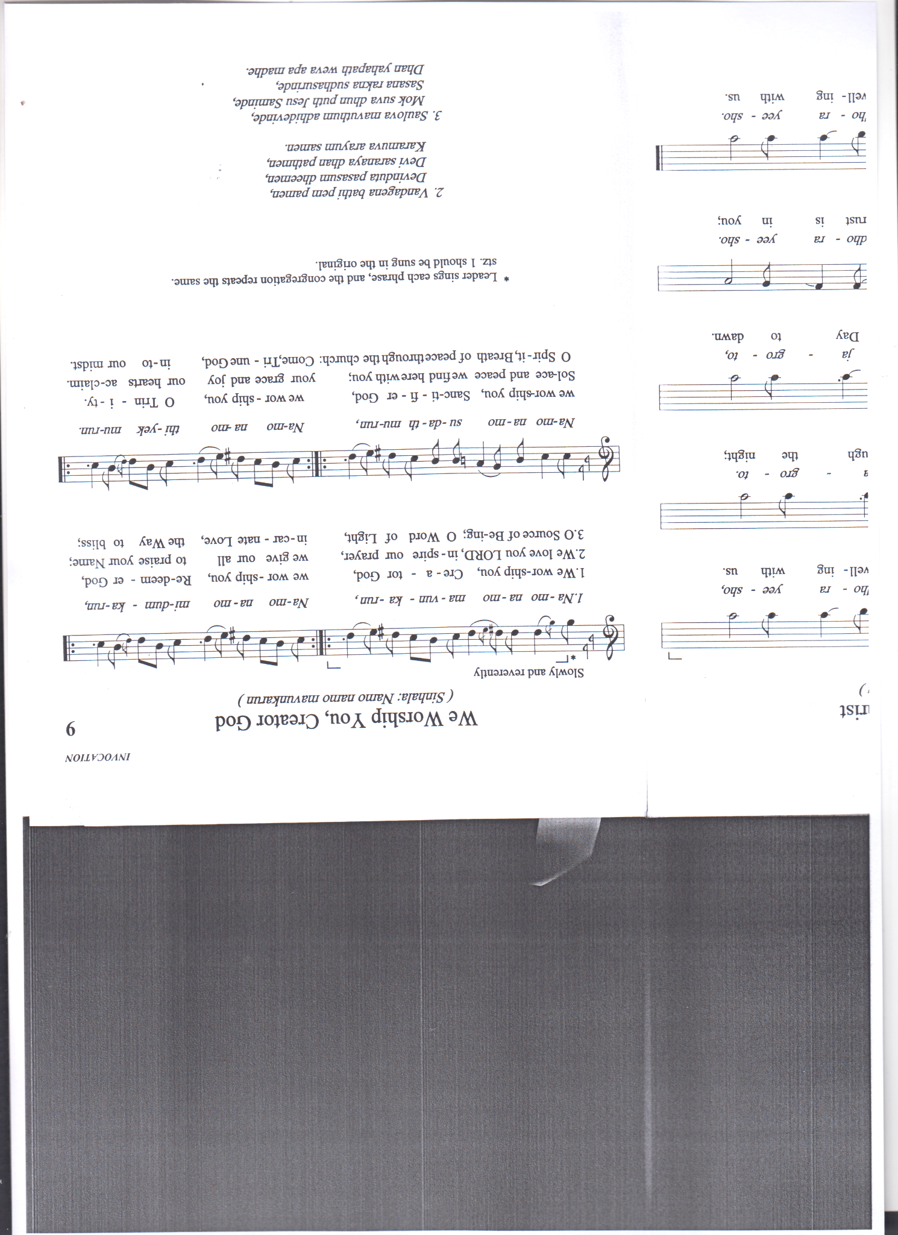
Words from Workers Mass, Sri Lanka
Music NAMO NAMO, Sri Lanka

The Procession of Symbols
(The symbols—The Bible, a lighted oil lamp, a bowl of rice (or any staple like bread, sweet potato, or sticky rice), an image or sculpture of interwoven hands, and an earthen vessel of water)
Litany of Invocation
Leader: Come, Spirit of God.
People: That we may walk the ancient paths of wisdom,
honouring those who have gone before us,
that we may gather at one table,
sharing the gifts of the earth and the labour of our hands,
that we may listen deeply to one another,
across languages, lands, and generations,

Leader: Unite us, O Christ.
People: Across the rivers and mountains that divide us,
across borders drawn by history,
across the wounds of war, the scars of colonisation,
and the struggles of migration,
across temples, churches, and house gatherings,
in whispered prayers and joyful songs,

Leader: Gather us as one people.
People: O God, as the bamboo bends but does not break,
teach us humility and strength,
O God, as the rivers meet the ocean,
may our many streams of faith flow into one,
O God, as the lotus blooms from the mud,
bring forth beauty from our brokenness,
O God, as the sun rises on every land, may your light guide us to unity,

Leader: Make us one in love and service.
People: For the healing of nations, for the peace of the world,
for the witness of your Church,
that we may walk as pilgrims together,
for the joy of your kindom, when all shall feast at your table,

All together: Come, O Spirit, breathe upon us.
Come, O Christ, walk among us.
Come, O God, make us one.
Psalm 133
Leader: How very good and pleasant it is
People: when kindred live together in unity!

Leader: It is like precious oil on the head,
running down upon the beard,
People: on the beard of Aaron,
running down over the collar of his robes.

Leader: It is like the dew of Hermon,
which falls on the mountains of Zion.
People: For there the Lord ordained his blessing,
life forevermore.
♫ All together: LORD, We Give You Heartfelt Praise
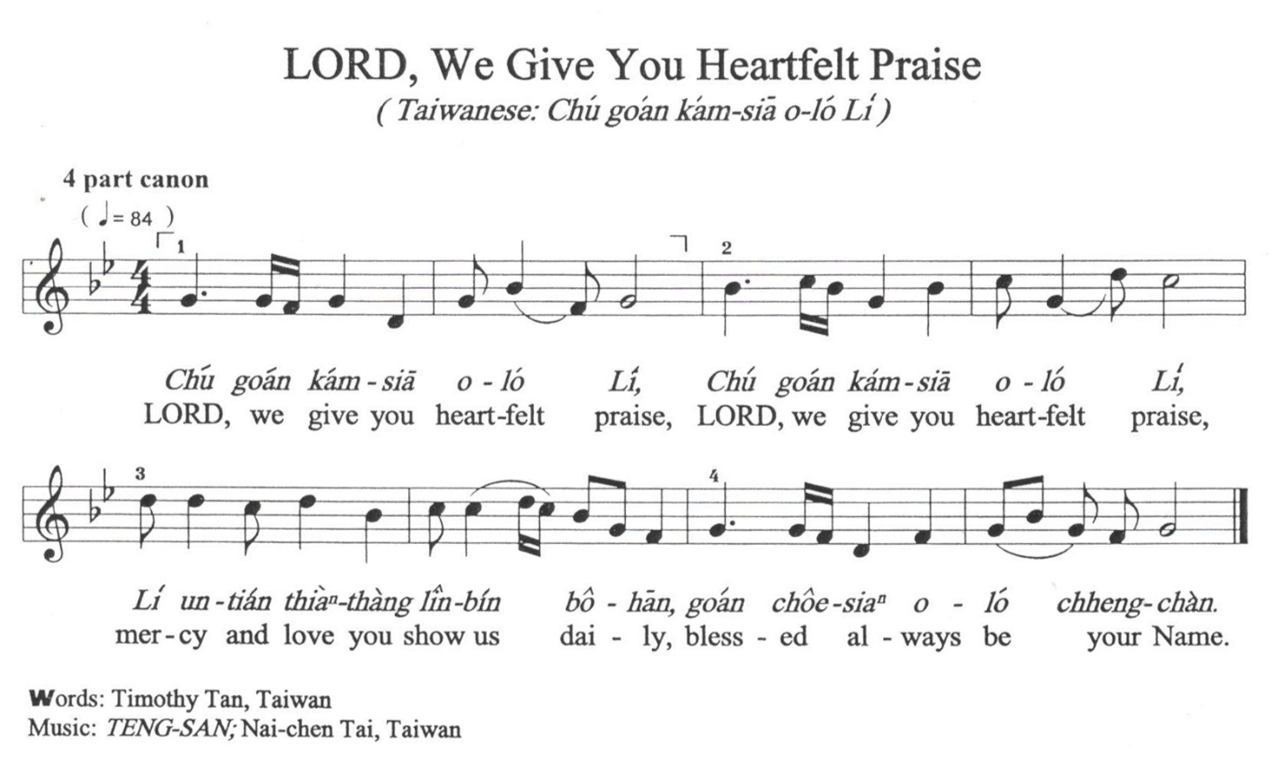

Prayer
Reader: Grace is not for the perfect alone,
but for those who stumble and rise again. So, let us sing—
For songs of truth soften hardened hearts,
and tears of sorrow lead to healing.

Sing, for the Spirit is drawn to the voices of the faithful,
to praises lifted in humility and love.
In our song, may discord cease, and harmony be restored.
In our confession, may division be healed, and unity renewed.

Let us come before God, seeking mercy and grace.
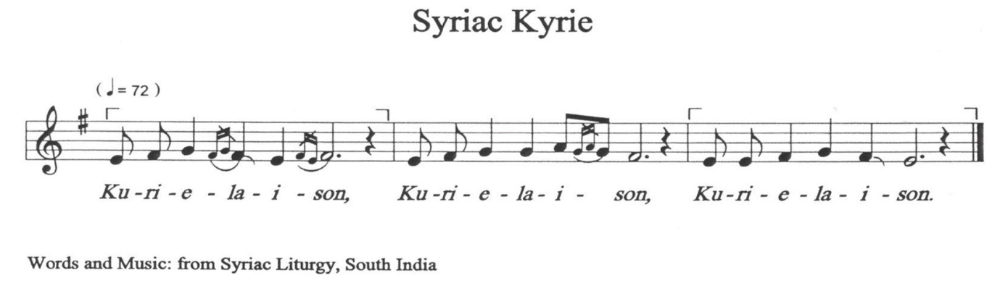

Act of Confession
Leader: How sorrowful and bitter it is when kindred live apart,
divided by strife and misunderstanding.
When blessings meant to flow freely are obstructed,
life becomes a struggle, void of peace and reconciliation.
How often have we failed to stand in unity, torn by differences and quarrels,
unable to reflect the unity Christ calls us to.

People: Call me by my name, O Lord.
When we turn away from the cries of our Asian siblings,
caught in the struggles of injustice, discrimination, and oppression,
when we allow our desires to divide us,
rather than seeking the peace you desire,
when we fail to be a body of unity,
torn by cultural and political divisions,
forgive us, O Lord, and bind us together in enduring faith and unity.
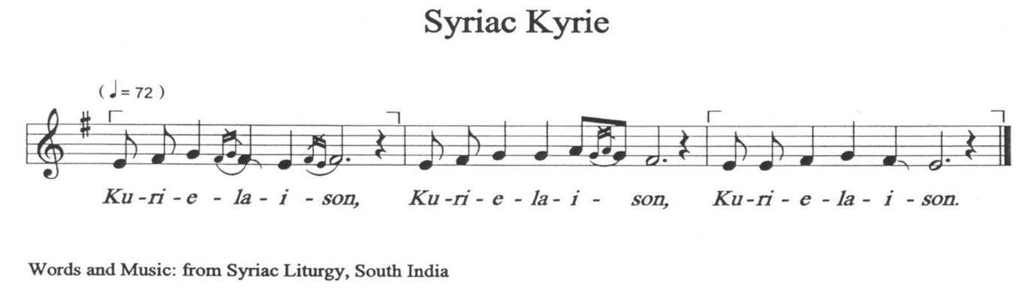

Leader: For the times we have fractured the body of Christ,
turning away from those who are different from us—by race, class, or culture,
for refusing to drink deeply from the one Spirit,
instead choosing pride, prejudice, and our own desires.
For the times when unprivileged people weep tears that are loud and deep.
We see their suffering, hear their struggles, and witness their staggering will to live.
Yet we remain only observers, failing to act with love and justice.

People: Call us by our name, O Lord.
When we see tears and turn away,
when we hear cries and ignore them,
when we stand idle in the face of suffering,
when our hearts grow hard, and our minds become filled with pride,
forgive us, O Lord, and lead us to respond with compassion and action.

Leader: For the times we have fallen short,
when sympathy, love, and tenderness
have been replaced with apathy and judgment,
for the times we have chosen ourselves over your gift of love,
for holding tightly to pride and selfishness,
when we have elevated ourselves above others,
forgetting humility and Christ’s call to serve.

People: Call us by our name, O Lord.
When we fail to show love and kindness,
when we turn a blind eye to the struggles of our neighbours,
when we walk in pride rather than humility,
forgive us, O Lord, and knit us together in the Spirit of Christ.

Leader: For the scattered people of the world: refugees;
fugitives from famine, drought, or war; orphaned children;
migrant workers; and those fleeing the stagnation and poverty of village life.
And for those living under systems of exclusion and oppression,
we admit our complicity in structures of injustice and our silence in their suffering.
We confess our indifference and neglect of their plight.

People: Call us by our name, O Lord.
For the times we failed to see their humanity,
for the walls we have built that separate us from their pain,
and for our unwillingness to share their burdens,
forgive us, O Lord, and teach us to walk alongside them.

Leader: For those who search for singers and prophets,
longing for signs of hope and redemption,
and for those who sing songs and proclaim truths beyond our comprehension,
we confess that we have failed to recognise their gifts
and join their mission of renewal.

People: Call us by our name, O Lord.
When we have dismissed their visions and silenced their voices,
when we have chosen to stay in the comfort of ignorance,
and when we have failed to seek the signs of your kindom,
forgive us, O Lord, and open our eyes to your work in the world.

Assurance of Pardon
Leader: People of God, hear the good news:
The One who calls us by name also gathers us in mercy.
God does not turn away from our cries but meets us with grace.
Christ, who walks among us, binds our wounds, restores our sight,
and leads us from brokenness into wholeness.

As rivers flow to the ocean, so does God’s mercy embrace us.
As the lotus blooms from the mud, so does grace arise from our repentance.
As the morning sun casts out the shadows of the night,
so does Christ’s love dispel our sins.

By the power of the Holy Spirit, we are forgiven,
renewed, and made one in Christ.
Thanks be to God! Amen.
For those who are able, please stand

Affirmation of Faith

Leader: Let us love one another, so that with oneness of mind,
we may confess the faith into which we were all baptised:
We believe in one God,
the Father, the Almighty,
maker of heaven and earth,
of all that is, seen and unseen.
We believe in one Lord, Jesus Christ,
the only Son of God,
eternally begotten of the Father,
Light from Light,
true God from true God,
begotten, not made;
of one Being with the Father.
Through him all things were made.
For us all, and for our salvation
he came down from heaven;
and was incarnate of the Holy Spirit and the virgin Mary,
and was made human.
For our sake he was crucified under Pontius Pilate;
he suffered death and was buried.
On the third day he rose from the dead in accordance with the scriptures.
He ascended to heaven
and is seated at the right hand of the Father.
He will come again in glory
to judge the living and the dead
and his kingdom will have no end.
We believe in the Holy Spirit,
the Lord, the giver of life,
who proceeds from the Father.
Who, with the Father and the Son, is worshipped and glorified,
who has spoken through the Prophets.
We believe in one, holy, catholic and apostolic Church.
We confess one baptism for the forgiveness of sins.
We look forward to the resurrection of the dead,
and to life in the age to come. Amen.

Sharing of Peace
Leader: Christ, who has called us by name, has reconciled us in love.
The peace we share is not our own, but a gift from God—
a peace that heals wounds, breaks down walls, and binds us together.
As we have been forgiven, let us also forgive;
as we have been embraced, let us also embrace.
The peace of Christ be with you all.
People: And also with you.

Leader: Let us share this peace with one another,
as signs of God’s enduring faith and unity.

(The people share the peace with one another.)

Please be Seated

Scripture Reading

Deuteronomy 6:4-9
“Hear, O Israel: The Lord is our God, the Lord alone. You shall love the Lord your God with all your heart and with all your soul and with all your might. Keep these words that I am commanding you today in your heart. Recite them to your children and talk about them when you are at home and when you are away, when you lie down and when you rise. Bind them as a sign on your hand, fix them as an emblem on your forehead, and write them on the doorposts of your house and on your gates.

1 Peter 1:3-9
Blessed be the God and Father of our Lord Jesus Christ! By his great mercy he has given us a new birth into a living hope through the resurrection of Jesus Christ from the dead and into an inheritance that is imperishable, undefiled, and unfading, kept in heaven for you, who are being protected by the power of God through faith for a salvation ready to be revealed in the last time. In this you rejoice, even if now for a little while you have had to suffer various trials, so that the genuineness of your faith—being more precious than gold that, though perishable, is tested by fire—may be found to result in praise and glory and honour when Jesus Christ is revealed. Although you have not seen him, you love him, and even though you do not see him now, you believe in him and rejoice with an indescribable and glorious joy, for you are receiving the outcome of your faith, the salvation of your souls.

♫ Your Word Will Be a Lamp to Guide Our Feet
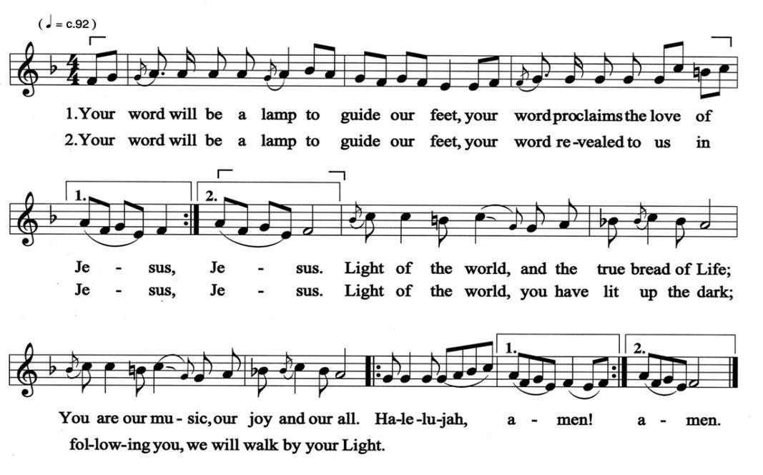
Words Anonymous; tr. Calvin Chelluah, Malaysia
Music KUTHU VILLEKU; Thamilz melody, Malaysia
John 20:24-29
But Thomas (who was called the Twin), one of the twelve, was not with them when Jesus came. So the other disciples told him, “We have seen the Lord.” But he said to them, “Unless I see the mark of the nails in his hands and put my finger in the mark of the nails and my hand in his side, I will not believe.”
A week later his disciples were again in the house, and Thomas was with them. Although the doors were shut, Jesus came and stood among them and said, “Peace be with you.” Then he said to Thomas, “Put your finger here and see my hands. Reach out your hand and put it in my side. Do not doubt but believe.” Thomas answered him, “My Lord and my God!” Jesus said to him, “Have you believed because you have seen me? Blessed are those who have not seen and yet have come to believe.”

Biblical Reflection/Sermon: ‘Nicaea – 1700: Enduring Faith and Embracing Unity’
♫ Hymn For Church Unity (Stanza 1-3)

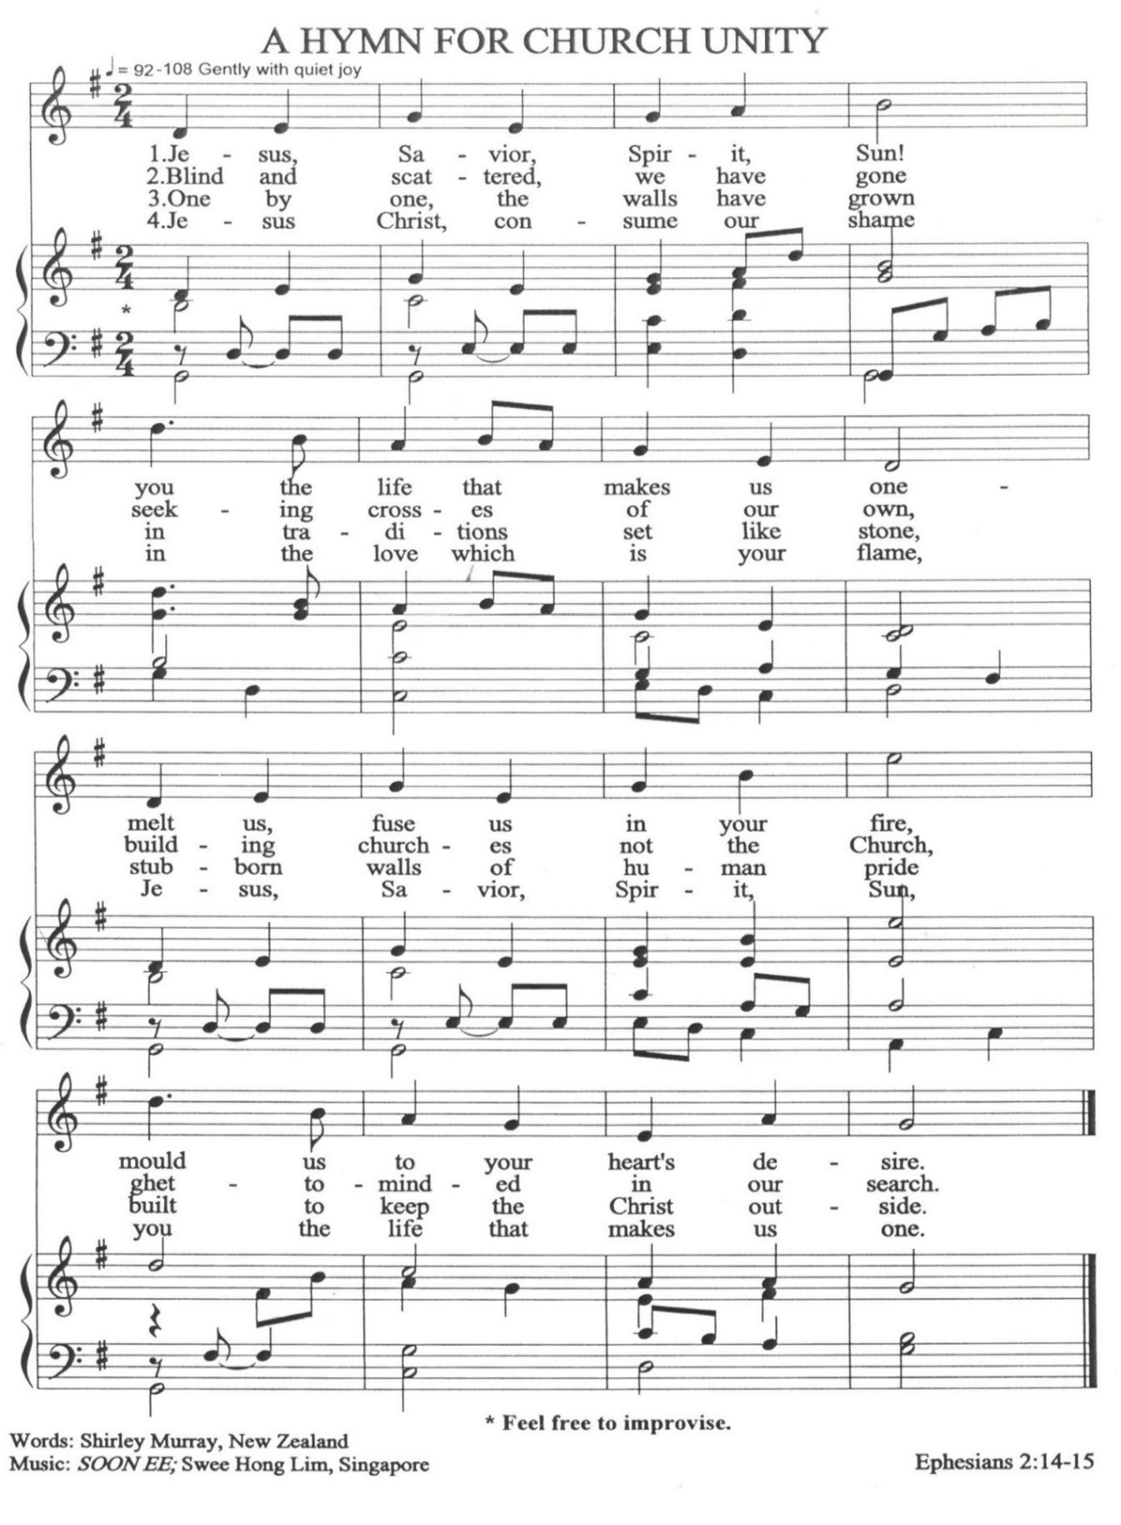
Prayer of Intercession
Leader: God of boundless mercy, you call us to a love that transcends all barriers—a love that embraces all, even those with whom we are at odds. In this moment, we come before you with open hearts, seeking to mirror your grace as we lift the needs of the world, our neighbours, and all your children. Draw us closer to your heart, that our prayers may be a reflection of your reconciling love.
Reader 1: We are all members of one another, but with different gifts according to the grace God gives us. (St Basil the Great, Bishop)
People: Lord of all gifts, we thank you for the diversity among us—the unique talents, perspectives, and experiences that enrich our community. Help us to recognise that these gifts are not for ourselves alone but are given for the good of all. Teach us to live in harmony as members of one body, appreciating the role each of us plays in building a world of justice and peace and fulfilling the calling you have placed on our lives.
Reader 2: You who were filled with divine love for humankind, inspire in us a heart full of kindness and love for each other. Strengthen our faith in God's providence and guide us in our efforts to live a life rooted in love and service. (Adapted from St Maria De Mattias)

People: God of unity, bless the gathering with your presence and guidance so that we may come together to pray, discern, and plan with sincere hearts. We come to you, O God, in this gathering to celebrate faith and to reaffirm the unity of our fellowship.

Reader 1: All been formed into one choir, to sing God’s song together and praise God with one voice through Jesus Christ, that when our Lord hears us God may realise from what we have done so well that we are of Christ’s members. (St Ignatius of Antioch)

People: God of wisdom and truth, renew our hearts and souls, through the guidance of your Holy Spirit, so that we may follow your will and courageously carry out your mission amidst the challenges thrown at us by the challenging times and the adversities of today. May you strengthen us to continuously commit and work for the building of God's reign on earth.

Reader 2: We beseech you to be our helper and protector. Save the afflicted among us; have mercy on the lowly; raise up the fallen; appear to the needy; heal the ungodly;
restore the wanderers of your people; feed the hungry; ransom our prisoners; raise the sick; comfort the faint-hearted. (St Clement of Rome)

All together: Compassionate God,
We pray for the people of Asia and around the world who are suffering from wars and hunger, those who are affected by illnesses and calamities, and those who are affected by human trafficking, domestic violence, statelessness, hate, discrimination, and indifference.

Touch our hearts so that we may be moved by your example of compassion for the othered, outcast, and marginalised. May we embrace with courage the call you have given us to do ministry to those who are treated unjustly by oppressive systems and powers.
Please pause for a moment of silence
Leader: Loving God, you have heard the prayers we have lifted before you. We ask that you transform our prayers into action, our faith into witness, and our hope into a source of strength for all who seek your presence.
May your Spirit continue to guide and inspire us as we journey together, united in purpose and committed to your call. Grant us grace to be living signs of your Kindom, reflecting your love in every place we go. May it be so!

Offertory

♫ Hymn For Church Unity (Stanza 4)

For those who are able, please stand

Prayer
All together:
Holy God, take us from where we are, to where you want us to be;
make us not merely guardians of a heritage,
but living signs of your coming Kindom;
fire us with passion for justice and peace
between all people; fill us with faith, hope, and love
which embody the Gospel;
and through the power of the Holy Spirit make us one.
That the world may believe,
that your name may be enthroned in our nation,
that your church may more effectively be your body,
we commit ourselves to love you, serve you,
and follow you as pilgrims, not strangers,
to the praise and honour of your name,
through Jesus Christ, your Son our Lord. May it be so!

Sending Forth
Benediction
Leader: May the God of Peace be with us
and grant us his peace at all times,
peace beyond our understanding,
that purifies the heart, mind, and body,
until his Kindom comes.
Having shared God’s love,
let us go into the world to share his love,
In the name of Christ.
People: May it be so!

You are encouraged to make
a special Asia Sunday Offering and contribute to
CCA’s Asia Solidarity Relief Fund

CCA Bank Account Details
Account Name: Christian Conference of Asia
Account No: 239-875156-883
Bank Name: Hang Seng Bank Limited
Bank Address: 83 Des Voeux Road Central, Hong Kong
Swift Code: HASEHKHHXXX

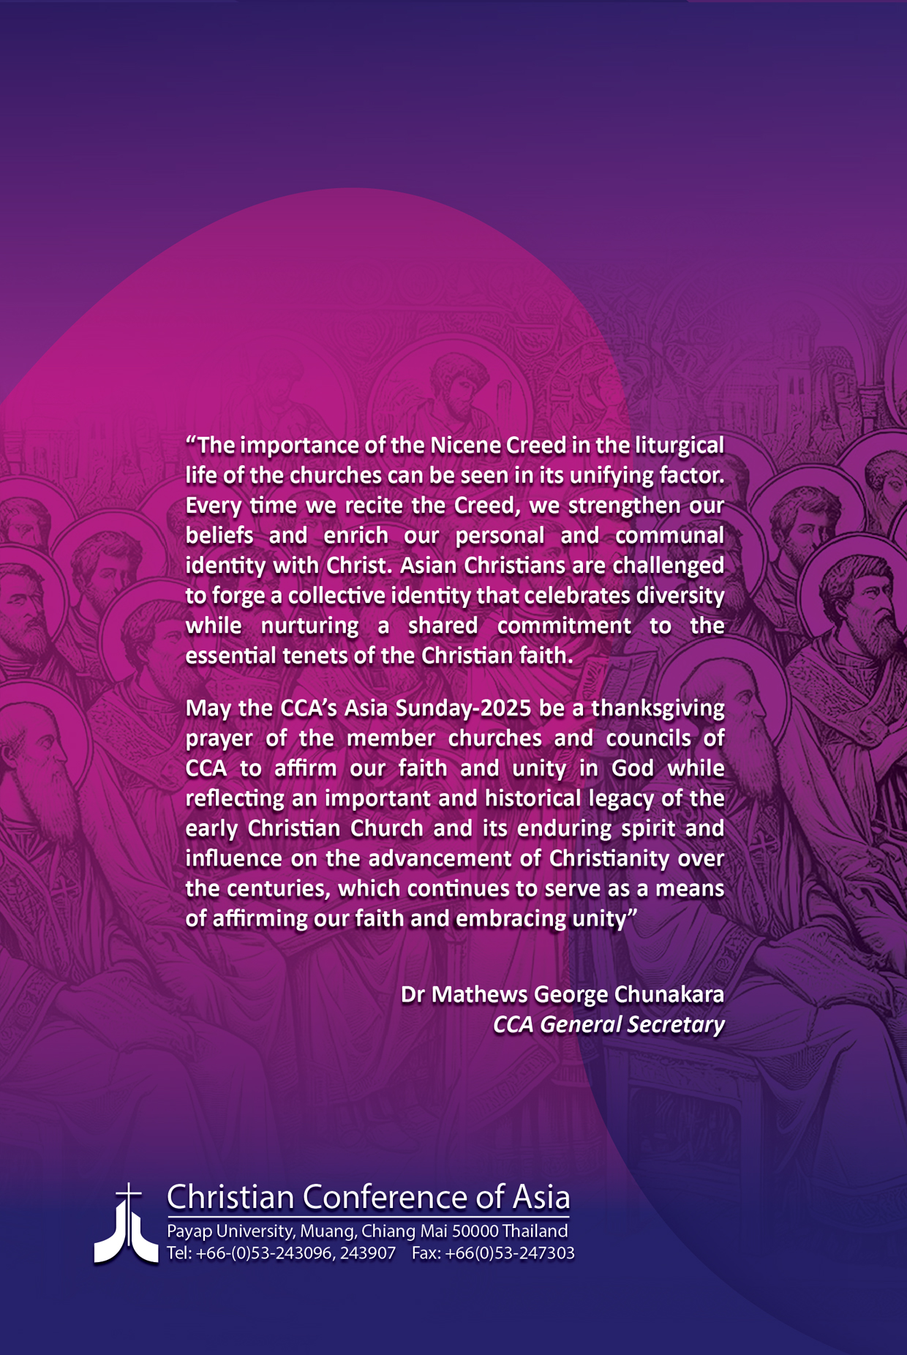

The elements presented here are suggestions. Communities are encouraged to adapt them according to their own cultural and spiritual traditions or use other symbols that best reflect their local expressions of faith, unity, and daily life.

